**浙大城市学院实验报告**

课程名称 计算机网络实验

实验项目名称 实验13 IPV6实验

学生姓名 司晨旭 专业班级 计算2002 学号 32001019

指导老师 蔡建平 实验日期 2022/4/22enn

一、实验目的

1.掌握IPV6的地址配置方法；

2.掌握IPV6的路由配置;

3.掌握IPV6隧道配置

二、实验设备

Packet Tracer模拟器软件；

Cisco 2911路由器若干台，PC机 6台。

三、实验内容

1. 静态路由实验

根据以下拓扑图，完成静态路由配置，实现全网可达，**要求将R1路由器命名为本人姓名的综写（在配置中显示）。**

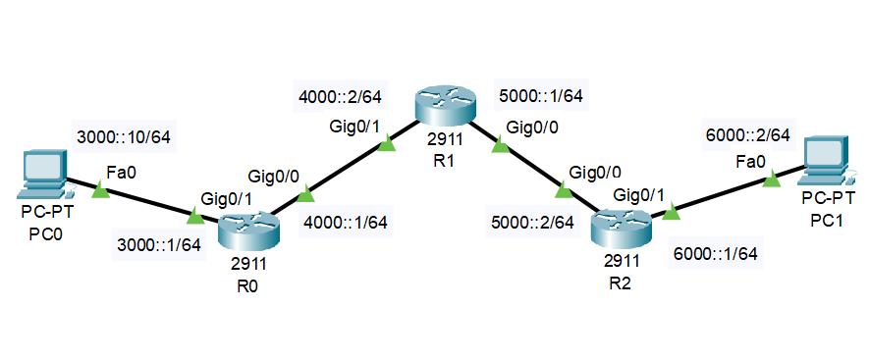

R0的配置：

|  |
| --- |
| Router>en  Router#conf t  Enter configuration commands, one per line. End with CNTL/Z.  Router(config)#hostname SCXR0  SCXR0(config)#interface g0/1  SCXR0(config-if)#ipv6 address 3000::1/64  SCXR0(config-if)#no shutdown  SCXR0(config-if)#  %LINK-5-CHANGED: Interface GigabitEthernet0/1, changed state to up  %LINEPROTO-5-UPDOWN: Line protocol on Interface GigabitEthernet0/1, changed state to up  SCXR0(config-if)#interface g0/0  SCXR0(config-if)#ipv6 address 4000::1/64  SCXR0(config-if)#no shutdown  SCXR0(config-if)#  %LINK-5-CHANGED: Interface GigabitEthernet0/0, changed state to up  SCXR0(config-if)#  %LINEPROTO-5-UPDOWN: Line protocol on Interface GigabitEthernet0/0, changed state to up  SCXR0 con0 is now available  Press RETURN to get started.  SCXR0>en  SCXR0#conf t  Enter configuration commands, one per line. End with CNTL/Z.  SCXR0(config)#ipv6 unicast-routing  SCXR0(config)#ipv6 route 5000::/64 4000::2  SCXR0(config)#ipv6 route 6000::/64 4000::2 |

R1的配置：

|  |
| --- |
| Router>  Router>en  Router#conf t  Enter configuration commands, one per line. End with CNTL/Z.  Router(config)#hostname SCXR1  SCXR1(config)#interface g0/1  SCXR1(config-if)#ipv6 address 4000::2/64  SCXR1(config-if)#no shutdown  SCXR1(config-if)#  %LINK-5-CHANGED: Interface GigabitEthernet0/1, changed state to up  %LINEPROTO-5-UPDOWN: Line protocol on Interface GigabitEthernet0/1, changed state to up  SCXR1(config-if)#interface g0/0  SCXR1(config-if)#ipv6 address 5000::1/64  SCXR1(config-if)#no shutdown  SCXR1(config-if)#  %LINK-5-CHANGED: Interface GigabitEthernet0/0, changed state to up  SCXR1(config-if)#  %LINEPROTO-5-UPDOWN: Line protocol on Interface GigabitEthernet0/0, changed state to up  SCXR1 con0 is now available  Press RETURN to get started.  SCXR1>en  SCXR1#conf t  Enter configuration commands, one per line. End with CNTL/Z.  SCXR1(config)#upv6 unicast-routing  ^  % Invalid input detected at '^' marker.  SCXR1(config)#ipv6 unicast-routing  SCXR1(config)#ipv6 route 3000::/64 4000::1  SCXR1(config)#ipv6 route 6000::/64 5000::2 |

R2的配置：

|  |
| --- |
| Router>en  Router#conf t  Enter configuration commands, one per line. End with CNTL/Z.  Router(config)#hostname SCXR2  SCXR2(config)#interface g0/0  SCXR2(config-if)#ipv6 address 5000::2/64  SCXR2(config-if)#no shutdown  SCXR2(config-if)#  %LINK-5-CHANGED: Interface GigabitEthernet0/0, changed state to up  %LINEPROTO-5-UPDOWN: Line protocol on Interface GigabitEthernet0/0, changed state to up  SCXR2(config-if)#interface g0/1  SCXR2(config-if)#ipv6 address 6000::1/64  SCXR2(config-if)#no shutdown  SCXR2(config-if)#  %LINK-5-CHANGED: Interface GigabitEthernet0/1, changed state to up  %LINEPROTO-5-UPDOWN: Line protocol on Interface GigabitEthernet0/1, changed state to up  SCXR2(config-if)#  SCXR2 con0 is now available  Press RETURN to get started.  SCXR2>en  SCXR2#conf t  Enter configuration commands, one per line. End with CNTL/Z.  SCXR2(config)#ipv6 unicast-routing  SCXR2(config)#ipv6 route 4000::/64 5000::1  SCXR2(config)#ipv6 route 3000::/64 5000::1 |

可达性结果测试：

PC0 => PC1

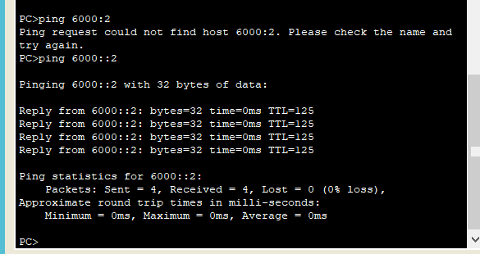

PC1 => PC0

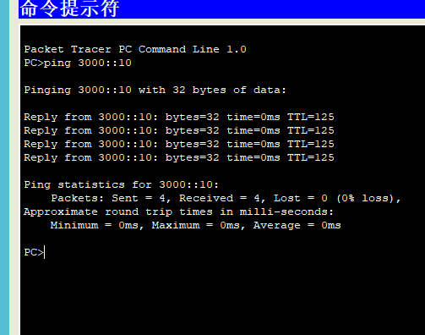

1. RIPv6实验

根据以下拓扑图，完成静态路由配置，实现全网可达，**要求将Router1路由器命名为本人姓名的综写（在配置中显示）。**

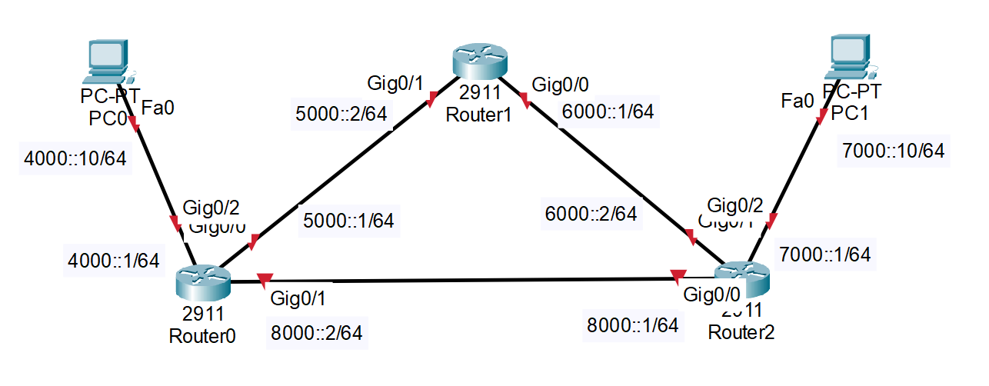

Router0的配置：

|  |
| --- |
| Router>en  Router#conf t  Enter configuration commands, one per line. End with CNTL/Z.  Router(config)#hostname SCXR0  SCXR0(config)#interface g0/2  SCXR0(config-if)#ip address 4000::1/64  ^  % Invalid input detected at '^' marker.  SCXR0(config-if)#ipv6 address 4000::1/64  SCXR0(config-if)#no shutdown  SCXR0(config-if)#  %LINK-5-CHANGED: Interface GigabitEthernet0/2, changed state to up  %LINEPROTO-5-UPDOWN: Line protocol on Interface GigabitEthernet0/2, changed state to up  SCXR0(config-if)#interface g0/0  SCXR0(config-if)#ipv6 address 5000::1/64  SCXR0(config-if)#no shutdown  SCXR0(config-if)#  %LINK-5-CHANGED: Interface GigabitEthernet0/0, changed state to up  SCXR0(config-if)#interface g0/1  SCXR0(config-if)#ipv6 address 8000::2/64  SCXR0(config-if)#no shutdown  SCXR0(config-if)#  %LINK-5-CHANGED: Interface GigabitEthernet0/1, changed state to up  SCXR0(config-if)#  SCXR0 con0 is now available  Press RETURN to get started.  %LINEPROTO-5-UPDOWN: Line protocol on Interface GigabitEthernet0/1, changed state to up  %LINEPROTO-5-UPDOWN: Line protocol on Interface GigabitEthernet0/0, changed state to up  SCXR0>en  SCXR0#conf t  Enter configuration commands, one per line. End with CNTL/Z.  SCXR0(config)#ipv6 router rip RIPV6  % IPv6 routing not enabled  SCXR0(config)#ipv6 unicast-routing  SCXR0(config)#ipv6 router rip RIPV6  SCXR0(config-rtr)#interface g0/0  SCXR0(config-if)#ipv6 rip RIPv6 enable  SCXR0(config-if)#interface g0/1  SCXR0(config-if)#ipv6 rip RIPv6 enable  SCXR0(config-if)#interface g0/2  SCXR0(config-if)#ipv6 rip RIPv6 enable |

Router1的配置：

|  |
| --- |
| Router>en  Router#conf t  Enter configuration commands, one per line. End with CNTL/Z.  Router(config)#hostname SCXR1  SCXR1(config)#interface g0/1  SCXR1(config-if)#ipv6 address 5000::2/64  SCXR1(config-if)#no shutdown  SCXR1(config-if)#  %LINK-5-CHANGED: Interface GigabitEthernet0/1, changed state to up  %LINEPROTO-5-UPDOWN: Line protocol on Interface GigabitEthernet0/1, changed state to up  SCXR1(config-if)#interface g0/0  SCXR1(config-if)#ipv6 address 6000::1/64  SCXR1(config-if)#no shutdown  SCXR1(config-if)#  %LINK-5-CHANGED: Interface GigabitEthernet0/0, changed state to up  %LINEPROTO-5-UPDOWN: Line protocol on Interface GigabitEthernet0/0, changed state to up  SCXR1(config-if)#  SCXR1(config-if)#exit  SCXR1(config)#ipv6 unicast-routing  SCXR1(config)#ipv6 router rip RIPV6  SCXR1(config-rtr)#interface g0/0  SCXR1(config-if)#ipv6 rip RIPv6 enable  SCXR1(config-if)#interface g0/1  SCXR1(config-if)#ipv6 rip RIPv6 enable  SCXR1(config-if)# |

Router2的配置：

|  |
| --- |
| Router>en  Router#conf t  Enter configuration commands, one per line. End with CNTL/Z.  Router(config)#hostname SCXR2  SCXR2(config)#interface g0/2  SCXR2(config-if)#ipv6 address 7000::1/64  SCXR2(config-if)#no shutdown  SCXR2(config-if)#  %LINK-5-CHANGED: Interface GigabitEthernet0/2, changed state to up  %LINEPROTO-5-UPDOWN: Line protocol on Interface GigabitEthernet0/2, changed state to up  SCXR2(config-if)#interface g0/0  SCXR2(config-if)#ipv6 address 8000::1/64  SCXR2(config-if)#no shutdown  SCXR2(config-if)#  %LINK-5-CHANGED: Interface GigabitEthernet0/0, changed state to up  %LINEPROTO-5-UPDOWN: Line protocol on Interface GigabitEthernet0/0, changed state to up  SCXR2(config-if)#interface g0/1  SCXR2(config-if)#ipv6 address 6000::2/64  SCXR2(config-if)#no shutdown  SCXR2(config-if)#  %LINK-5-CHANGED: Interface GigabitEthernet0/1, changed state to up  SCXR2(config-if)#  %LINEPROTO-5-UPDOWN: Line protocol on Interface GigabitEthernet0/1, changed state to up  SCXR2 con0 is now available  Press RETURN to get started.  SCXR2>en  SCXR2#conf t  Enter configuration commands, one per line. End with CNTL/Z.  SCXR2(config)#ipv6 unicast-routing  SCXR2(config)#ipv6 router rip RIPV6  SCXR2(config-rtr)#interface g0/0  SCXR2(config-if)#ipv6 rip RIPv6 enable  SCXR2(config-if)#interface g0/1  SCXR2(config-if)#ipv6 rip RIPv6 enable  SCXR2(config-if)#interface g0/2  SCXR2(config-if)#ipv6 rip RIPv6 enable |

可达性结果测试：

PC0 => PC1

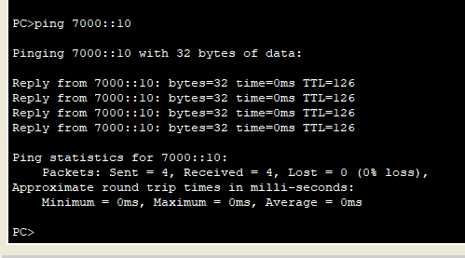

PC1 => PC0

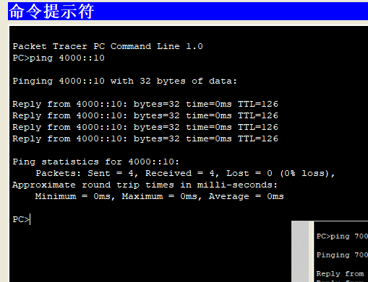

1. IPV6隧道实验

根据以下拓扑图，完成静态路由配置，实现全网可达，**要求将R2路由器命名为本人姓名的综写（在配置中显示）。**

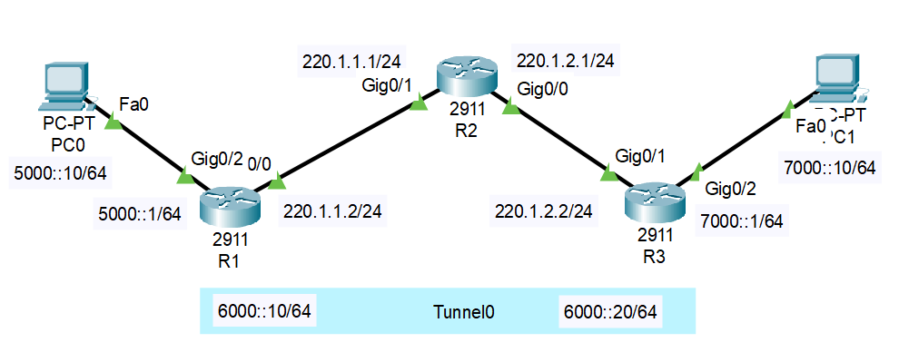

R1的配置：

|  |
| --- |
| Router>en  Router#conf t  Enter configuration commands, one per line. End with CNTL/Z.  Router(config)#hostname SCXR0  SCXR0(config)#interface g0/2  SCXR0(config-if)#ipv6 address 5000::1/64  SCXR0(config-if)#no shutdown  SCXR0(config-if)#  %LINK-5-CHANGED: Interface GigabitEthernet0/2, changed state to up  %LINEPROTO-5-UPDOWN: Line protocol on Interface GigabitEthernet0/2, changed state to up  SCXR0(config-if)#interface g0/0  SCXR0(config-if)#ip address 220.1.1.2 255.255.255.0  SCXR0(config-if)#no shutdown  SCXR0(config-if)#  %LINK-5-CHANGED: Interface GigabitEthernet0/0, changed state to up  SCXR0(config-if)#  %LINEPROTO-5-UPDOWN: Line protocol on Interface GigabitEthernet0/0, changed state to up  SCXR0 con0 is now available  Press RETURN to get started.  SCXR0>en  SCXR0#conf t  Enter configuration commands, one per line. End with CNTL/Z.  SCXR0(config)#interface Tunnel 0  SCXR0(config-if)#  %LINK-5-CHANGED: Interface Tunnel0, changed state to up  SCXR0(config-if)#ipv6 address 6000::10/64  SCXR0(config-if)#tunnel source g0/0  SCXR0(config-if)#tunnel destination 220.1.2.2  SCXR0(config-if)#tunnel mode ipv6ip  SCXR0(config-if)#  %LINEPROTO-5-UPDOWN: Line protocol on Interface Tunnel0, changed state to up  SCXR0(config-if)#exit  SCXR0(config)#ipv6 unicast-routing  SCXR0(config)#ipv6 route 7000::0/64 6000::20  SCXR0(config)#ip route 0.0.0.0 0.0.0.0 220.1.1.1  SCXR0(config)#  SCXR0#  %SYS-5-CONFIG_I: Configured from console by console |

R2的配置：

|  |
| --- |
| Router>en  Router#conf t  Enter configuration commands, one per line. End with CNTL/Z.  Router(config)#hostname SCXR2  SCXR2(config)#interface g0/1  SCXR2(config-if)#ip address 220.1.1.1 255.255.255.0  SCXR2(config-if)#no shutdown  SCXR2(config-if)#  %LINK-5-CHANGED: Interface GigabitEthernet0/1, changed state to up  %LINEPROTO-5-UPDOWN: Line protocol on Interface GigabitEthernet0/1, changed state to up  SCXR2(config-if)#interface g0/0  SCXR2(config-if)#ip address 2201.2.1 255.255.255.0  ^  % Invalid input detected at '^' marker.  SCXR2(config-if)#ip address 220.1.2.1 255.255.255.0  SCXR2(config-if)#no shutdown  SCXR2(config-if)#  %LINK-5-CHANGED: Interface GigabitEthernet0/0, changed state to up  SCXR2(config-if)#  %LINEPROTO-5-UPDOWN: Line protocol on Interface GigabitEthernet0/0, changed state to up |

R3的配置：

|  |
| --- |
| Router>en  Router#conf t  Enter configuration commands, one per line. End with CNTL/Z.  Router(config)#hostname SCXR3  SCXR3(config)#interface g0/1  SCXR3(config-if)#ip address 220.1.2.2 255.255.255.0  SCXR3(config-if)#no shutdown  SCXR3(config-if)#  %LINK-5-CHANGED: Interface GigabitEthernet0/1, changed state to up  %LINEPROTO-5-UPDOWN: Line protocol on Interface GigabitEthernet0/1, changed state to up  SCXR3(config-if)#interface g0/2  SCXR3(config-if)#ipv6 7000::1/64  ^  % Invalid input detected at '^' marker.  SCXR3(config-if)#ipv6 address 7000::1/64  SCXR3(config-if)#no shutdown  SCXR3(config-if)#  %LINK-5-CHANGED: Interface GigabitEthernet0/2, changed state to up  %LINEPROTO-5-UPDOWN: Line protocol on Interface GigabitEthernet0/2, changed state to up  SCXR3(config-if)#exit  SCXR3(config)#interface tunnel 0  SCXR3(config-if)#  %LINK-5-CHANGED: Interface Tunnel0, changed state to up  SCXR3(config-if)#ipv6 address 6000::20/64  SCXR3(config-if)#no shutdown  SCXR3(config-if)#tunnel sourece g0/1  ^  % Invalid input detected at '^' marker.  SCXR3(config-if)#tunnel source g0/1  SCXR3(config-if)#tunnel destination 220.1.1.2  SCXR3(config-if)#tunnel mode ipv6ip  SCXR3(config-if)#  %LINEPROTO-5-UPDOWN: Line protocol on Interface Tunnel0, changed state to up  SCXR3(config-if)#ipv6 unicast-routing  SCXR3(config)#ipv6 route 5000::/64 6000::10  SCXR3(config)#ip route 0.0.0.0 0.0.0.0 220.1.2.1 |

可达性结果测试：

PC0 => PC1

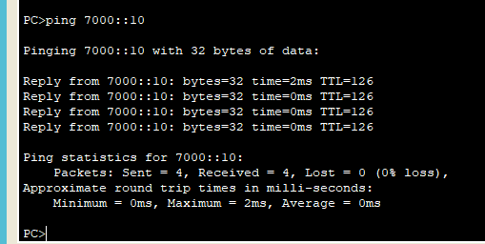

PC1 => PC0

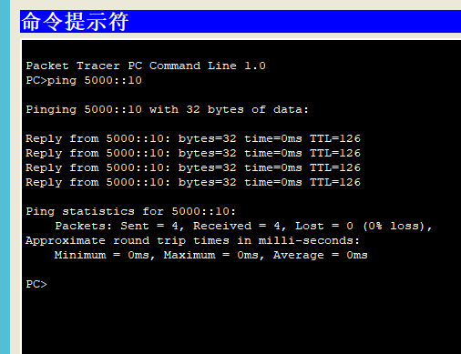

五、收获感想：

记录实验感受、操作过程中遇到的困难及解决办法、遗留的问题、意见和建议等。

就，这次实验做的很顺利，感觉这次的和先前的差不多